The Dynamic Actor Workshop: Week Four

"The more you do your homework, the more you're free to be intuitive. But you've got to put the work in."
- Edward Norton

"The trick is to take the work seriously, but not take yourself seriously at all"
- Judy Dench

“Acting touches the nerves you have absolutely no control over.”
- Alan Rickman

As we make decisions about the scene – the driving action, potential tactics – we risk getting stuck in the intellectual part of our brains. But these decisions should strike nerves and ignite imagery. If they don’t, they aren’t the right decisions. We’ll spend some time this week calling forth that imagery and seeing how it drives us. Chekhov’s Psychological Gesture describes a mind-body connection that has become more popular in the broader culture lately with concepts like Power Posing. We can awaken instincts by letting your body lead your mind.

Similarly, the “as if” creates a vividly imagined space for you to activate your physical engagement in a driving action, allowing you to carry that feeling over into active and playful scene work.

In the end, we are looking to create pathways to the nerves that Rickman describes. Once we hit those nerves, we can step aside and let intuition carry us.

Gesture and Visualization – Bringing words to life
“All languages use idiomatic expressions related to physical activity and gesture to describe complicated psychological states. These imagined movements, which have become enchanted in our speech and thought, are gestures of everyday life. But as applies to our psychological life, we produce them in our minds instead of in our bodies. This is the only significant difference between the two kinds of gestures, since their actual nature remains the same.
We ‘grasp’ the idea just as we grasp the physical object. We ‘touch’ upon the problem just as we touch upon an unknown surface in our physical surroundings.
. . . What does one do inwardly while uttering such expressions as these?
To draw a conclusion
To kill the thought
To touch upon the problem
To burst into tears
To give comfort
To break connections
To grasp the idea
To sidestep the responsibility
To jump into the excitement
To fall into despair
To grow pensive

It would be a misunderstanding to conclude that we mean that while we are ‘breaking’ our connections with somebody, we are actually producing breaking gestures in our mind as with our arms and hands. What we do mean is that the tendency to produce such a gesture undoubtedly exists in our mind . . . . The psychological state in which the actor finds his character gives him the full opportunity to see it as the Action (or Gesture) with appropriate Qualities and Images. Thus, we may say that the same movement in one case is physical (Gesture) and in the other psychological (Qualities and Images).

. . . The plain meaning, the ‘what’ of the word, will never be lost, since the actor understands what the author speaks about, but the ‘how’ will suffer greatly if the actor does not build it on the basis of a dynamic Gesture with its demonstrative qualities. ‘If speech is to be made plastic on the one hand, musical on the other,’ wrote Rudolf Steiner, ‘then this is first of all a matter of bringing gesture into the speech.’

The actor exercises the Gesture as long as is needed to stir his inner life. The Psychological Gesture becomes for him a kind of a first, rough, charcoal draft for the future picture, after which all the details will gradually emerge and cover the initial sketch.”

-Michael Chekhov, On the Technique of Acting

Some Psychological Gesture sketches from On the Technique of Acting:

Picasso’s Absinthe Drinker
Egon Schiele – Self Portrait
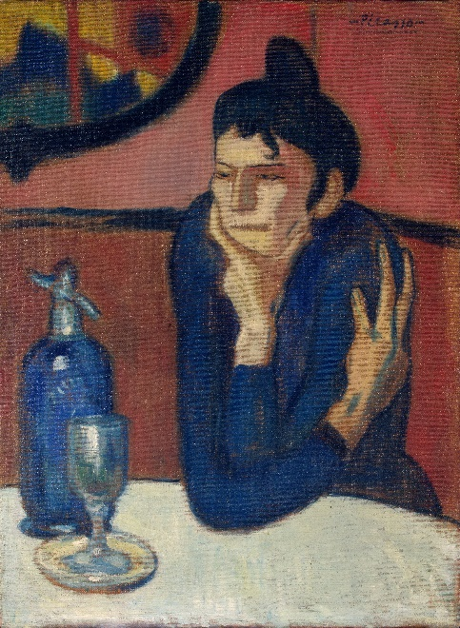
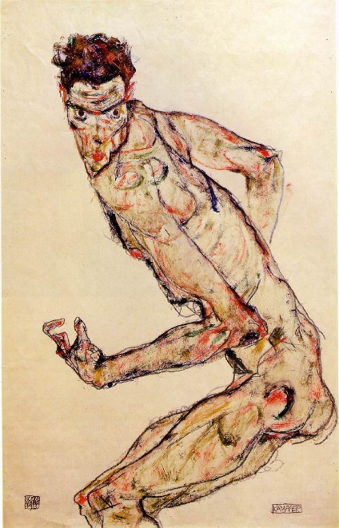

The As If

The as if is about creating the feeling of having a tangible, personal stake in your driving action. The as if is:
- Something that could actually happen to you; if it’s a fantasy, it isn’t personal
- Simple and direct – pare it down as much as you can
- A preparatory tool – not something you play in the scene, but a means of preparing for the scene

If your driving action in the scene is “I am begging a loved one’s forgiveness,” your as-if should have that same driving action. Done well, the as-if awakens your sense of play, sets a physical readiness to invest in the scene, and gets some skin in the game by reminding you of the stakes – what will happen if you don’t get what you want?

Suggested reading: A Practical Handbook for the Actor by various authors

I don’t agree with every word of it, but this is the most straightforward explanation of Practical Aesthetics, the essential action, and the as if. Simple, clear, and concise.

